Appendix D – Fishbone Analysis

It’s the purpose of this document to describe how to perform a fishbone analysis in ArcGIS, essentially, a fishbone analysis takes where an address will geocode along a centerline and compares that to the actual address location. The analysis is a useful quality control tool. For example, if a fishbone line crosses across a centerline this would indicate a parity issues exists with the assigned address ranges. This document assumes the fishbone analysis is being performed on a centerline dataset with address range and zip code assignments.

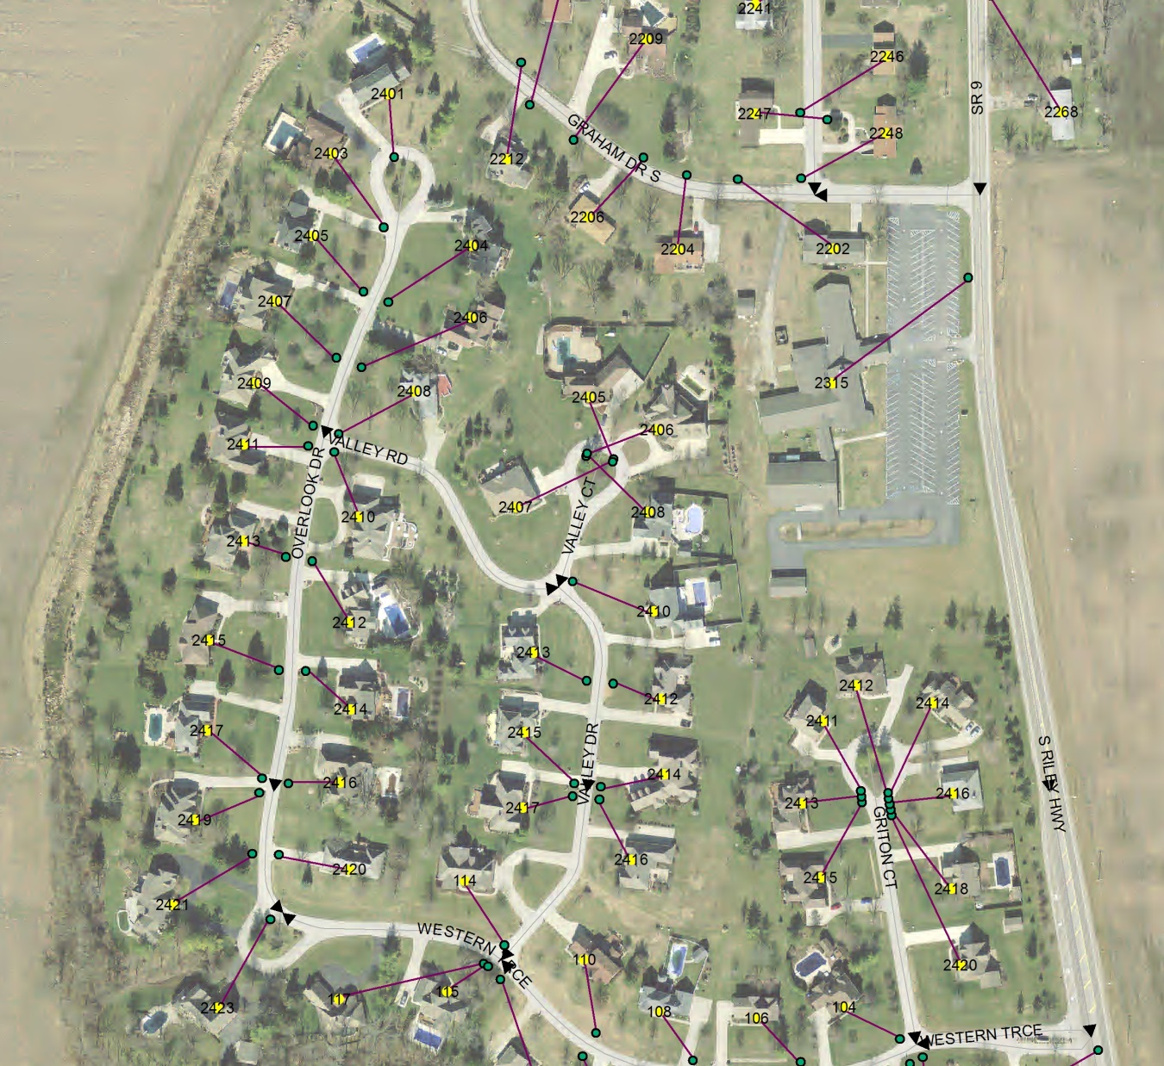

Step 1 - Preparation

Use ArcCatalog to create a new file geodatabase with a feature dataset inside it. Import the centerlines you wish to perform the fishbone analysis on into the feature dataset.

Step 2 – Address Locator

At the feature dataset level, right click in ArcCatalog and select New🡪Address Locator

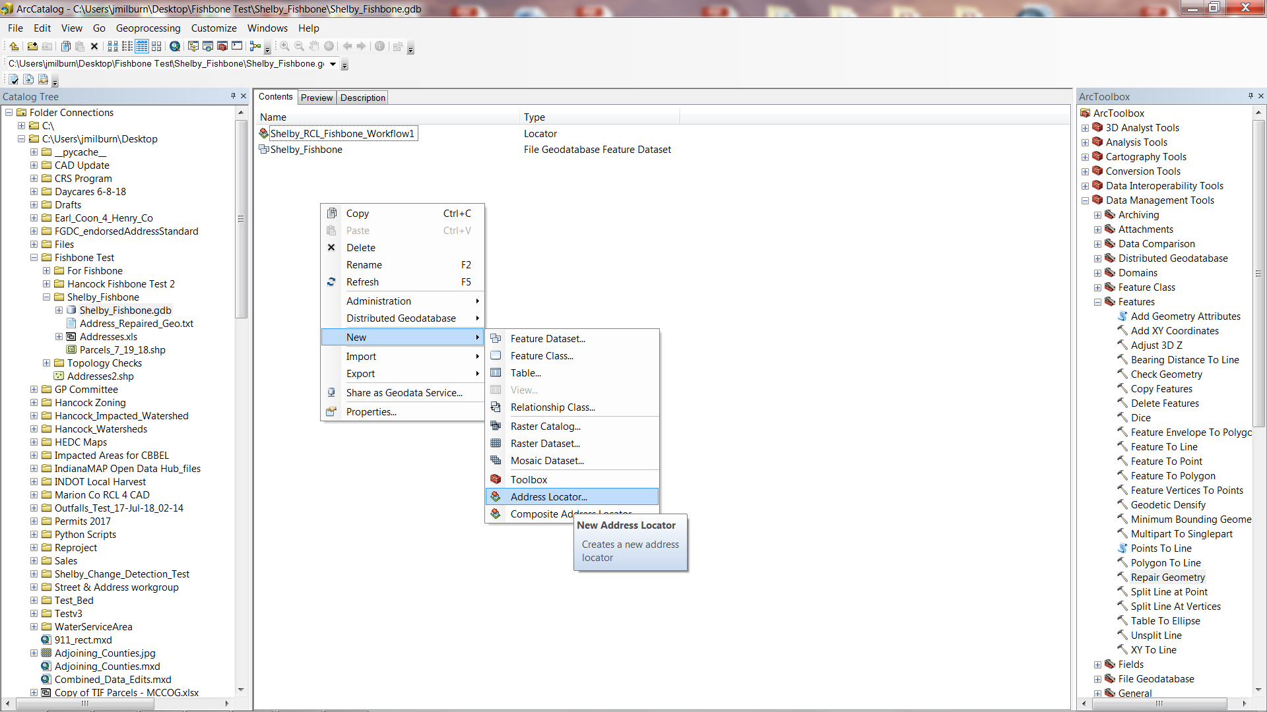

For the Address Locator Style select, ‘US Address – Dual Range’. Use the centerline dataset you imported into the file geodatabase as the Reference Data. If your centerlines are using a Caliber schema the Field Map will auto-populate the correct field names and no further changes need to be made. Click OK.

Step 3 – Export Address Points as a Shapefile

If you maintain address point data of the subject area in a geodatabase you’ll need to export that data to a shapefile. In Windows Explorer, navigate to the location the shapefile is located and open its associated .dbf file in Excel (or whatever spreadsheet software you use) and save it as a .txt file or other file type you can add to ArcMap.

Step 4 – Geocode .txt file Using Address Locator

Make sure the geocoding toolbar is active in ArcMap. Add the address locator you created to ArcMap by dragging and dropping it from ArcCatalog or selecting it using the geocoding toolbar. Add the address point .txt file to ArcMap. Click Geocode Addresses on the geocoding toolbar. Select the address locator you created and the address point .txt file as your address table. Use Multiple Fields for your Address Input Fields and point to the full address field and zip code field in your address point table. Click OK.

Step 5 – Clean up Unmatched and Tied Results

If this is the first time anyone’s ever geocoded this counties address point table along its centerline dataset then you probably have a lot of work to do before you conduct a fishbone analysis. Before you begin go to ArcToolbox🡪Data Management Tools🡪Features🡪Repair Geometry and perform a repair. Don’t delete null features until you note which streets are null features as you’ll need to check these later. Uncheck this box if you haven’t done this.

Your geocoding results table will refresh more quickly if you export it out as a shapefile and use that instead of the initial results table for QC. Most geocoding errors are pretty obvious when you review the centerline and address point data. One of the more problematic reasons for an address not to geocode correctly is due to conflicting zip code assignments. The only way many of these can be fixed is to cut a centerline multiple times and assign the correct zip code to each piece. It may not be worth your time to go through all the trouble involved. If working with large datasets it’s advisable to decide what you’re policy will be for these in the beginning. In a NG9-1-1 system these will go away but it’s still a problem in some legacy systems.

Also be sure to check Score % in your geocoding results table. Depending on your geocoding settings, ambiguities in the address table can result in a match when the result should have been a tie. It may be worth doing a quick scan of matches with a score of less than 100% so you can identify these.

Step 6 – Add X, Y and join Fields in a Copies of Results Table and Address Points

Add three fields to copies of your geocoding results table and address point data, a field to store X values (make sure both X tables don’t have the same name), a field to store Y values (make sure both Y tables don’t have the same name) and join field to link your geocoding results with your address points.

Run calculate geometry on your X and Y fields to populate them. Performing a field calculation in the join fields that set them equal to full address and zip code is probably sufficient. After this is done join the two datasets and export them out as a single feature.

Step 7 - XY To Line

In ArcToolbox go to Data Management🡪Features🡪XY to Line. Fill in the blanks with the exported feature you just created. \*Poof\* you have a fishbone analysis. If you have unmatched addresses that didn’t geocode their associated fishbone lines will point somewhere way off the map. You may wish to delete these (they’ll be easy to spot if you zoom out). The second problem you’ll notice is probably related to ambiguities, for example you may have lines associated with 123 N 500 E that point to 123 N 500 W so they draw across the entire map, after these are cleaned up its easier to spot issues related to parity, for example when a fishbone line crosses across a centerline.

Between clearing up issues related to geocoding your address point table to your street centerlines and reviewing the fishbone analysis results and making corrections your centerline dataset should be pretty solid once you’re done (assuming it’s been rectified to the MSAG).